**Bachelor of Engineering (Honours) in Software and Electronic Engineering**

**GMIT Department of Electrical and Electronic Engineering**

**Year 1**

**Industrial Automation**

**Gabriel Farragher 2022**

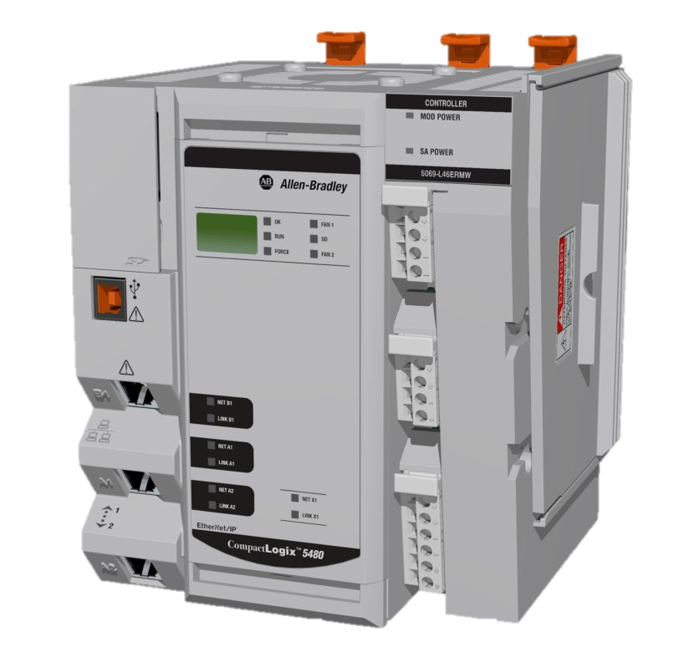

# Student Details:

* **Date: January – April 2022**
* **Module: Industrial Automation**
* **Student Name:**
* **Student Number:**
* **Lecturer: Gabriel Farragher**
* **Document: Lab Reports**

# Table of Contents:

1 Student Details: 2

2 Table of Contents: 3

3 Table of Figures: 3

4 GX Works 2– Lab 3 Exercise 1 – I/O: 5

# Table of Figures:

**No table of figures entries found.**

**Notes:**

|  |
| --- |
|  |
|  |
|  |
|  |
|  |
|  |
|  |
|  |
|  |
|  |
|  |
|  |
|  |
|  |
|  |
|  |
|  |
|  |
|  |
|  |

# GX Works 2– Lab 3 Exercise 1 – I/O:

**Lab Overview:**

* **Develop skills towards programming larger PLC applications.**
* **Develop pre-skills for sequence programming.**
* A Momentary Start Push Button [**iStart_PB**] is used to send a run signal to a conveyor belt.
* A momentary Stop Push Button [**iStop_PB**] is used to stop conveyor.
* A Proximity Sensor [**iProx_Sensor**] is used to count the products at the accumulation section.
* If the Product Count is below the setpoint **oProduct_Low** Lamp is On.
* When 5 products have accumulated, the conveyor pauses.
* **oProduct_Full** Lamp turns On.
* The system is then Reset using the **iReset_PB**.
* Develop the Ladder Logic for this operation.
* When the system is stopped both lamps are Off.
* Include Comments.

**PLC I/O Addresses:**

* **iStart_PB X1**
* **iStop_PB X2**
* **iProx_Sensor X3**
* **iReset X4**
* **oConveyor Y0**
* **oProduct_Low Y1**
* **oProduct_Full Y2**

**[Note: Save PLC software file as: GX W2 L3 Ex 1 GF B]**

